Training a classifier = learning the weights

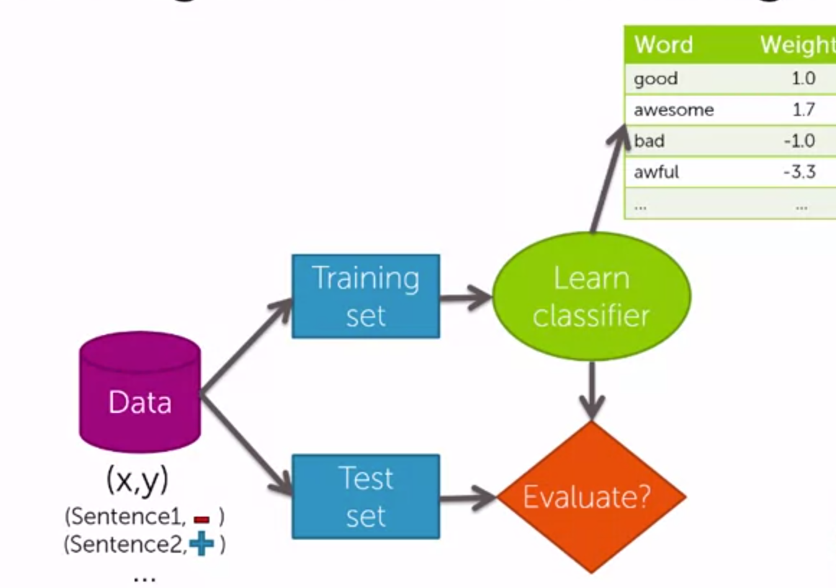

How do we measure classification error?

We take the sentence “sushi is great” and feed it to the classifier. We do so while hiding the label. We than look at the output generated by the classifier and compare it to the label. If it is correct, we add it to correct sentences else we add it to mistakes.

One way of measuring error is to divide the number of mistakes by the total number of tests.

We also have accuracy where we divide the number of corrects by the total number of tests.

Also: error = 1 – accuracy; and accuracy = 1 - error